1. Mode Sequence

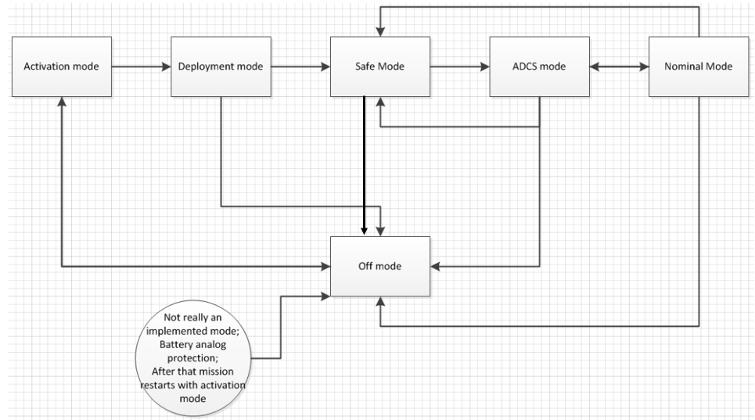

2. Function flow in every mode

2.1 Things to do in every mode (TDEM)

(For OBC, there are several modes; for other modules, there is no mode!)

**For OBC**

**TDEM-OBC-1.**

Kick its internal and external watchdogs periodically.

*Note:*

*Internal watchdog time window: 178s*

*External watchdog time window: 2.5s*

**TDEM-OBC-2.**

Request commands of the ground from COMMS.

**TDEM-OBC-3.**

Check and execute commands in TDEM-OBC-2 one by one.

**TDEM-OBC-4.**

Request telemetry from other active modules.

*Note:*

*1 OBC does not do it for specific modules in a specific mode. If OBC fail to turn on/off a module, it still knows the status.*

*2 OBC pings all modules to see which one is online and then request telemetry. OBC can also read telemetry from EPS first and then determine which module to be requested. If OBC fail to turn on/off a module, it still knows the status.*

*3 Do it at least once every 178s, otherwise the internal watchdogs in slave modules will reset their boards.*

**TDEM-OBC-5.**

Do health check according to telemetry in TDEM-OBC-4.

**TDEM-OBC-6.**

Compute current uptime since last boot and total uptime.

**TDEM-OBC-7.**

Measure voltage of its power line as part of its telemetry.

**TDEM-OBC-8.**

Check the mode flag and the voltage (TDEM-OBC-7) to determine which mode it should be.

If voltage < SM voltage **AND** (mode flag != “activation mode” **OR** “deployment mode”)

Mode flag = “safe mode”;

Switch the mode according to the mode flag.

**TDEM-OBC-9.**

Copy the specified variables in the list, commands in TDEM-OBC-2, telemetry in TDEM-OBC-4/6/7/8, health status in TDEM-OBC-5 to FRAM.

*Note: we only keep the recent status in FRAM.*

**TDEM-OBC-10.**

Store the specified variables in the list, commands in TDEM-OBC-2, telemetry in TDEM-OBC-4/6/7/8, health status in TDEM-OBC-5 in the SD card in every TBD seconds.

*Note: we keep all historical records in the SD card.*

**TDEM-OBC-11.**

Communication, i.e.

If battery voltage > SM voltage **AND** TX is on:

Command COMMS to send packages to the ground station in every TBD second;

**For COMMS**

**TDEM-COMMS-1.**

Kick its internal watchdog periodically.

**TDEM-COMMS-2.**

Kick its external watchdog if it gets a valid command.

**TDEM-COMMS-3.**

Receive commands from the ground station and save them in the buffer.

**TDEM-COMMS-4.**

If OBC requests the commands in TDEM-COMMS-3, pass them to OBC.

**TDEM-COMMS-5.**

Collect its telemetry.

**TDEM-COMMS-6.**

If OBC requests the telemetry in TDEM-COMMS-5, pass it to OBC.

**TDEM-COMMS-7.**

Listen to OBC to turn on/off RX and TX.

*Note: Every time COMMS boots, TX is off, and RX is on by default.*

**TDEM-COMMS-8.**

If TX is on and COMMS gets packages from OBC, pass the packages to the ground station.

**For EPS**

**TDEM-EPS-1. (hardware mechanism)**

Monitor voltage of the battery.

If < 2.8V, turn power line V1~4 off.

If > 2.8V, turn power line V1 (OBC, COMMS, ADB) on. Other lines are off by default.

*Note: If the kill switch is released, EPS will always be on.*

**TDEM-EPS-2.**

Kick its internal watchdog periodically.

**TDEM-EPS-3.**

Kick its external watchdog if it gets a valid command.

**TDEM-EPS-4.**

If the battery voltage > 2.8V, listen to OBC’s commands to manage other power lines.

**TDEM-EPS-5.**

Collect its telemetry.

**TDEM-EPS-6.**

If OBC requests the telemetry in TDEM-EPS-5, pass it to OBC.

**For ADB**

**TDEM-ADB-1.**

Kick its internal watchdog periodically.

**TDEM-ADB-2.**

Kick its external watchdog if it gets a valid command.

**TDEM-ADB-3.**

Listen to OBC’s commands to deploy the antenna.

**TDEM-ADB-4.**

Collect its telemetry.

**TDEM-ADB-5.**

If OBC requests the telemetry in TDEM-ADB-4, pass it to OBC.

**For ADCS**

**TDEM-ADCS-1.**

Kick its internal watchdog periodically.

**TDEM-ADCS-2.**

Kick its external watchdog if it gets a valid command.

**TDEM-ADCS-3.**

Listen to OBC’s commands to start/stop detumbling.

**TDEM-ADCS-4.**

Collect its telemetry (including the rotational speed).

**TDEM-ADCS-5.**

If OBC requests the telemetry in TDEM-ADCS-4, pass it to OBC.

2.2 Activation mode (AcM)

**For OBC**

**REMEMBER TO CLEAN FRAM BEFORE THE LAUNCH!!!**

**AcM-OBC-1.**

Load data from FRAM (which will be used in the following modes).

If there is no data, use default values.

**AcM-OBC-2.**

Copy the recent (specified) variables in the list, telemetry, and health status from FRAM to the SD card.

*Note:*

*1. Such record is used as core dump.*

*2. Such records should have special signs in the SD card, like “core dump”.*

**AcM-OBC-3.**

Set boot count = recorded value + 1.

**AcM-OBC-4.**

Command EPS to turn off other power lines except V1.

**AcM-OBC-5.**

Check whether the activation time is passed:

If “activation status” == “expired”:

mode flag = “deployment mode”;

Skip the following work in activation mode;

Else if “activation status” == “unexpired” **AND** total uptime <= “end of activation status”:

Do nothing;

Else if “activation status” == “unexpired” **AND** total uptime > “end of activation status”:

mode flag = “deployment mode”;

“activation status” = “expired”;

*Note:*

*“Activation status” and “end of activation status” will be loaded from the FRAM in AcM-OBC-1.*

*This task always starts from the status before the last reboot.*

2.3 Deployment mode (DpM)

**For OBC**

**DpM-OBC-1.**

Check whether deployment is done according to deployment flag.

If deployment status == “deployed”,

mode flag = “safe mode”;

Skip the following work in this mode;

else,

Go to DpM-OBC-2;

*Note:*

*“Deployment status” will be loaded from the FRAM in AcM-OBC-1.*

*This task always starts from the status before the last reboot.*

**DpM-OBC-2.**

Check whether deployment is done according to telemetry of ADB (collected in TDEM-OBC-4).

If telemetry shows the antenna is deployed:

“deployment status” = “deployed”;

“mode flag” = “safe mode”;

Skip the following work in this mode;

If the deployment is not done:

Go to DpM-OBC-3;

**DpM-OBC-3.**

Check battery voltage against the deploying voltage.

Check “deployment status” and “end of deployment status”.

If “deployment status” == “normal deployment” **AND** total uptime < “end of deployment status”:

If battery voltage > “deploying voltage”:

command ADB to deploy the antenna;

“deployment status” = “delaying”;

“end of deployment status” = total uptime + “delaying parameter”;

else if “deployment status” == “normal deployment” **AND** total uptime >= “end of deployment status”:

“deployment status” = “forced deployment”;

else if “deployment status” == “forced deployment”:

command ADB to deploy the antenna;

“deployment status” = “delaying”;

“end of deployment status” = total uptime + “delaying parameter”;

else if “deployment status” == “delaying” **AND** total uptime < “end of deployment status”:

do nothing;

else if “deployment status” == “delaying” **AND** total uptime >= “end of deployment status”:

“deployment status” = “normal deployment”;

“end of deployment status” = total uptime + “forced deployment parameter”;

*Note:*

*“Deployment status” and “end of XX” will be loaded from the FRAM in AcM-OBC-1.*

*This task always starts from the status before the last reboot.*

2.4 Safe mode (SfM)

**For OBC**

**SfM-OBC-1.**

Copy the recent (specified) variables in the list, telemetry and health status from FRAM to the SD card.

*Note:*

*1. Such record is used as core dump.*

*2. Such records should have special signs in the SD card, like “core dump”.*

**SfM-OBC-2.**

Command COMMS to switch TX on.

**SfM-OBC-3.**

Command EPS to turn off other power lines except V1.

**SfM-OBC-4.**

If battery voltage > SM voltage and the results of health check (TDEM-OBC-5) is OK, set the mode flag as “ADCS mode”.

2.5 ADCS mode (ADCSM)

**For OBC**

**ADCSM-OBC-1.**

Check the ADCS status.

If the status is “disabled”, set the mode flag as “nominal mode” and skip the following work in this mode.

If not, go to ADCSM-OBC-2.

*Note:*

*“ADCS status” will be loaded from the FRAM in AcM-OBC-1.*

*This task always starts from the status before the last reboot.*

**ADCSM-OBC-2.**

Initialize ADCS power line, i.e.

Command EPS to turn power line V2 (ADCS) on;

“ADCS power status” = “initializing”;

“end of ADCS power status” = total uptime + TBD second;

If “ADCS power status” == “initializing” **AND** total uptime < “end of ADCS power status”:

Skip the following work in this mode;

else if “ADCS power status” == “initializing” **AND** total uptime >= “end of ADCS power status””:

“ADCS power status” = “initialized”;

Skip the following work in this mode;

else If “ADCS power status” == “initialized”:

If health check result (in TDEM-OBC-4) is good:

Go to ADCSM-OBC-3;

else if health check result is bad:

Command EPS to power cycle line V2 (ADCS);

“ADCS power status” = “power cycling”;

“end of ADCS power status” = total uptime + “power cycle parameter”;

Skip the following work in this mode;

else if “ADCS power status” == “power cycling” **AND** total uptime < “end of ADCS power status”:

Skip the following work in this mode;

else if “ADCS power status” == “power cycling” **AND** total uptime >= “end of ADCS power status”:

If health check result (in TDEM-OBC-4) is good:

“ADCS power status” = “initialized”;

Go to ADCSM-OBC-3;

else if health check result is bad:

Command EPS to turn line V2 (ADCS) off;

“ADCS power status” = “off”;

“ADCS status” = “disabled”;

“mode flag” = “safe mode”;

Skip the following work in this mode;

*Note:*

*1.* ***No*** *variables here will be loaded from the FRAM in AcM-OBC-1.*

*This task will be* ***initialized again every time OBC enters ADCS mode****.*

*2. We can treat other power lines in this way.*

*However, OBC should* ***never*** *manage power line V1 (OBC, COMMS, ADB).*

**ADCSM-OBC-3.**

Check rotational speed according to telemetry collected in TDEM-OBC-4, i.e.

If “ADCS status” == “idle”:

If “rotational speed” > “rotational speed limit”:

Command ADCS to detumble;

“ADCS status” = “detumbling”

“end of ADCS status” = total uptime + “detumbling period parameter”;

else if “rotational speed” < “rotational speed limit”:

“ADCS status” = “idle”;

“mode flag” = “nominal mode”;

else if “ADCS status” == “detumbling” **AND** total uptime < “end of ADCS status”:

If “rotational speed” > “rotational speed limit”:

Command ADCS to detumble;

else if “rotational speed” <“rotational speed limit”:

Command ADCS to stop detumbling;

“ADCS status” = “idle”;

“mode flag” = “nominal mode”;

else if “ADCS status” == “detumbling” **AND** total uptime > “end of ADCS status”:

Command ADCS to stop detumbling;

“ADCS status” = “disabled”;

“mode flag” = “safe mode”;

*Note:*

*These variables will be loaded from the FRAM in AcM-OBC-1.*

*This task always starts from the status before the last reboot.*

2.6 Nominal mode (NoM)

**NoM-OBC-1.**

Command EPS to turn on power line V4.

**NoM-OBC-2.**

Determine the rotation speed, i.e.

If “rotational speed” > “rotational parameter” **AND** ADCS flag == “enabled”

“mode flag” = “ADCS mode”;

Skip the following work in this mode;

else if “rotational speed” > “rotational parameter” **AND** ADCS flag == “disabled”

“mode flag” = “safe mode”;

Skip the following work in this mode;

**NoM-OBC-3.**

…

**NoM-OBC-4.**

Power budget

3 Variable list for OBC

|  |  |  |  |  |  |  |  |  |
| --- | --- | --- | --- | --- | --- | --- | --- | --- |
| **In every mode** | | | | | | | | |
| **Variable in OBC** | **Type** | **In FRAM?** | **In SD card?** | **In downlink?** | **Changeable by ground?** | **Default value** | **Load from FRAM during booting?**  **(AcM-OBC-1)** | **Copy from FRAM to SD card as core dump? (AcM-OBC-2/SfM-OBC-1)** |
| Mode flag | enum | Yes | Yes | Yes | Yes (only for SRAM) | Activation mode | No | Yes |
| Boot count | long | Yes | Yes | Yes | No | 0 | Yes | Yes |
| Uptime since last boot | long | Yes | Yes | Yes | No | 0 | No | Yes |
| Total uptime | long | Yes | Yes | Yes | No | 0 | Yes | Yes |
| Battery voltage | ushort | Yes | Yes | Yes | No | 0 | No | Yes |
| Telemetry from modules | / | Yes | Yes | Yes | No | / | No | Yes |
| Health check results | / | Yes | Yes | Yes | No | / | No | Yes |
| **Activation mode** | | | | | | | | |
| Activation status | enum | Yes | Yes | Yes | Yes (SRAM + FRAM) | Not done | Yes | Yes |
| End of activation status | long | Yes | Yes | Yes | Yes (SRAM + FRAM) | 0 | Yes | Yes |
| **Deploying mode** | | | | | | | | |
| Deployment status | enum | Yes | Yes | Yes | Yes (SRAM + FRAM) | Normal deployment | Yes | Yes |
| End of deployment status | long | Yes | Yes | Yes | Yes (SRAM + FRAM) | 10h | Yes | Yes |
| Deploying voltage | ushort | Yes | Yes | Yes | Yes (SRAM + FRAM) | 3.3V | Yes | Yes |
| Forced deployment parameter | long | Yes | Yes | Yes | Yes (SRAM + FRAM) | 10h | Yes | Yes |
| Delaying parameter | long | Yes | Yes | Yes | Yes (SRAM + FRAM) | 3min | Yes | Yes |
| **Safe mode** | | | | | | | | |
| SM voltage | long | Yes | Yes | Yes | Yes (SRAM + FRAM) | 3.6V | Yes | Yes |
| **ADCS mode** | | | | | | | | |
| ADCS status | enum | Yes | Yes | Yes | Yes (SRAM + FRAM) | idle | Yes | Yes |
| End of ADCS status | long | Yes | Yes | Yes | Yes (SRAM + FRAM) | 0 | Yes | Yes |
| Rotational speed | ushort | Yes | Yes | Yes | No | 0 | No | Yes |
| Rotational speed limit | ushort | Yes | Yes | Yes | Yes (SRAM + FRAM) | 5 deg/s | Yes | Yes |
| Detumbling period parameter | long | Yes | Yes | Yes | Yes (SRAM + FRAM) | TBD | Yes | Yes |
| ADCS power status | enum | Yes | Yes | Yes | No | Not initialized | No | Yes |
| End of ADCS power status | long | Yes | Yes | Yes | No | 0 | No | Yes |
| Power cycle parameter | long | Yes | Yes | Yes | Yes (SRAM + FRAM) | 16s | Yes | Yes |